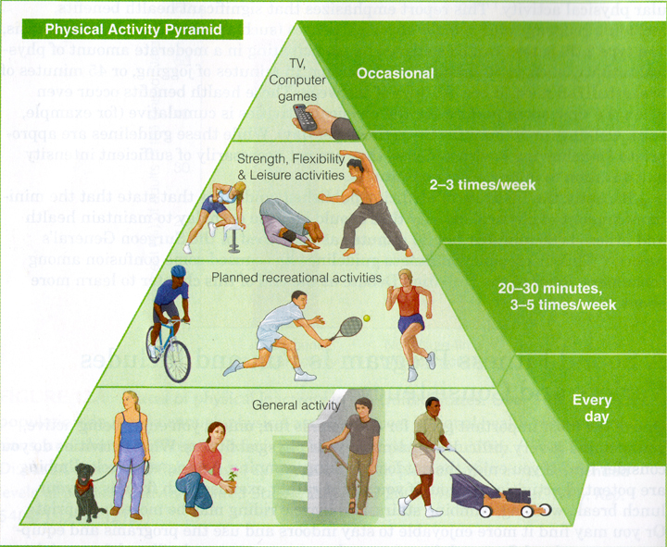

**Directions: Using the examples within the Physical Activity Pyramid,** chart below by“Coloring in” or placing an “X” in one square for each day of the week that you participated in that type of activity.

|  |  |  |  |  |
| --- | --- | --- | --- | --- |
| Weekday | **Occasional**  **Activities** | **Strength, Flexibility, &Leisure Activities** | **Planned Recreational Activities** | **Everyday**  **Activities** |
| **Sunday** |  |  |  |  |
| **Monday** |  |  |  |  |
| **Tuesday** |  |  |  |  |
| **Wednesday** |  |  |  |  |
| **Thursday** |  |  |  |  |
| **Friday** |  |  |  |  |
| **Saturday** |  |  |  |  |